Shapes
# Source: AI Source: Provided by: [Data Path: Persons Table -> ID Column: 1, Name_En Column: Motasem Essam] -> From: [ChatGPT] on [7/25/2026]
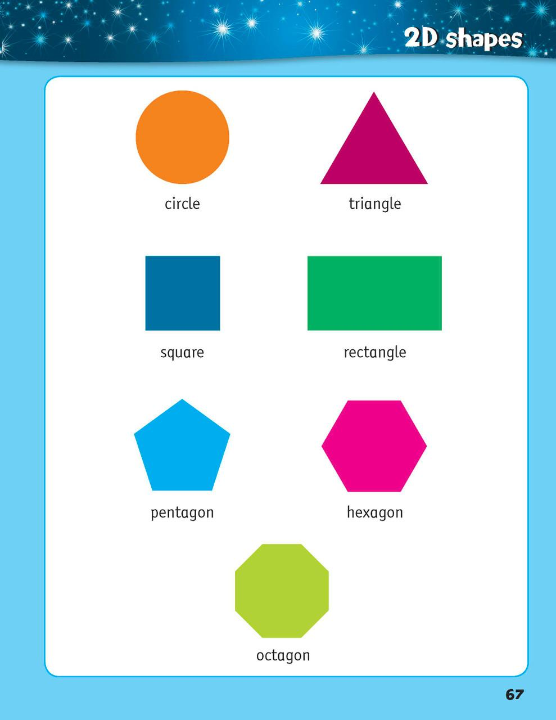
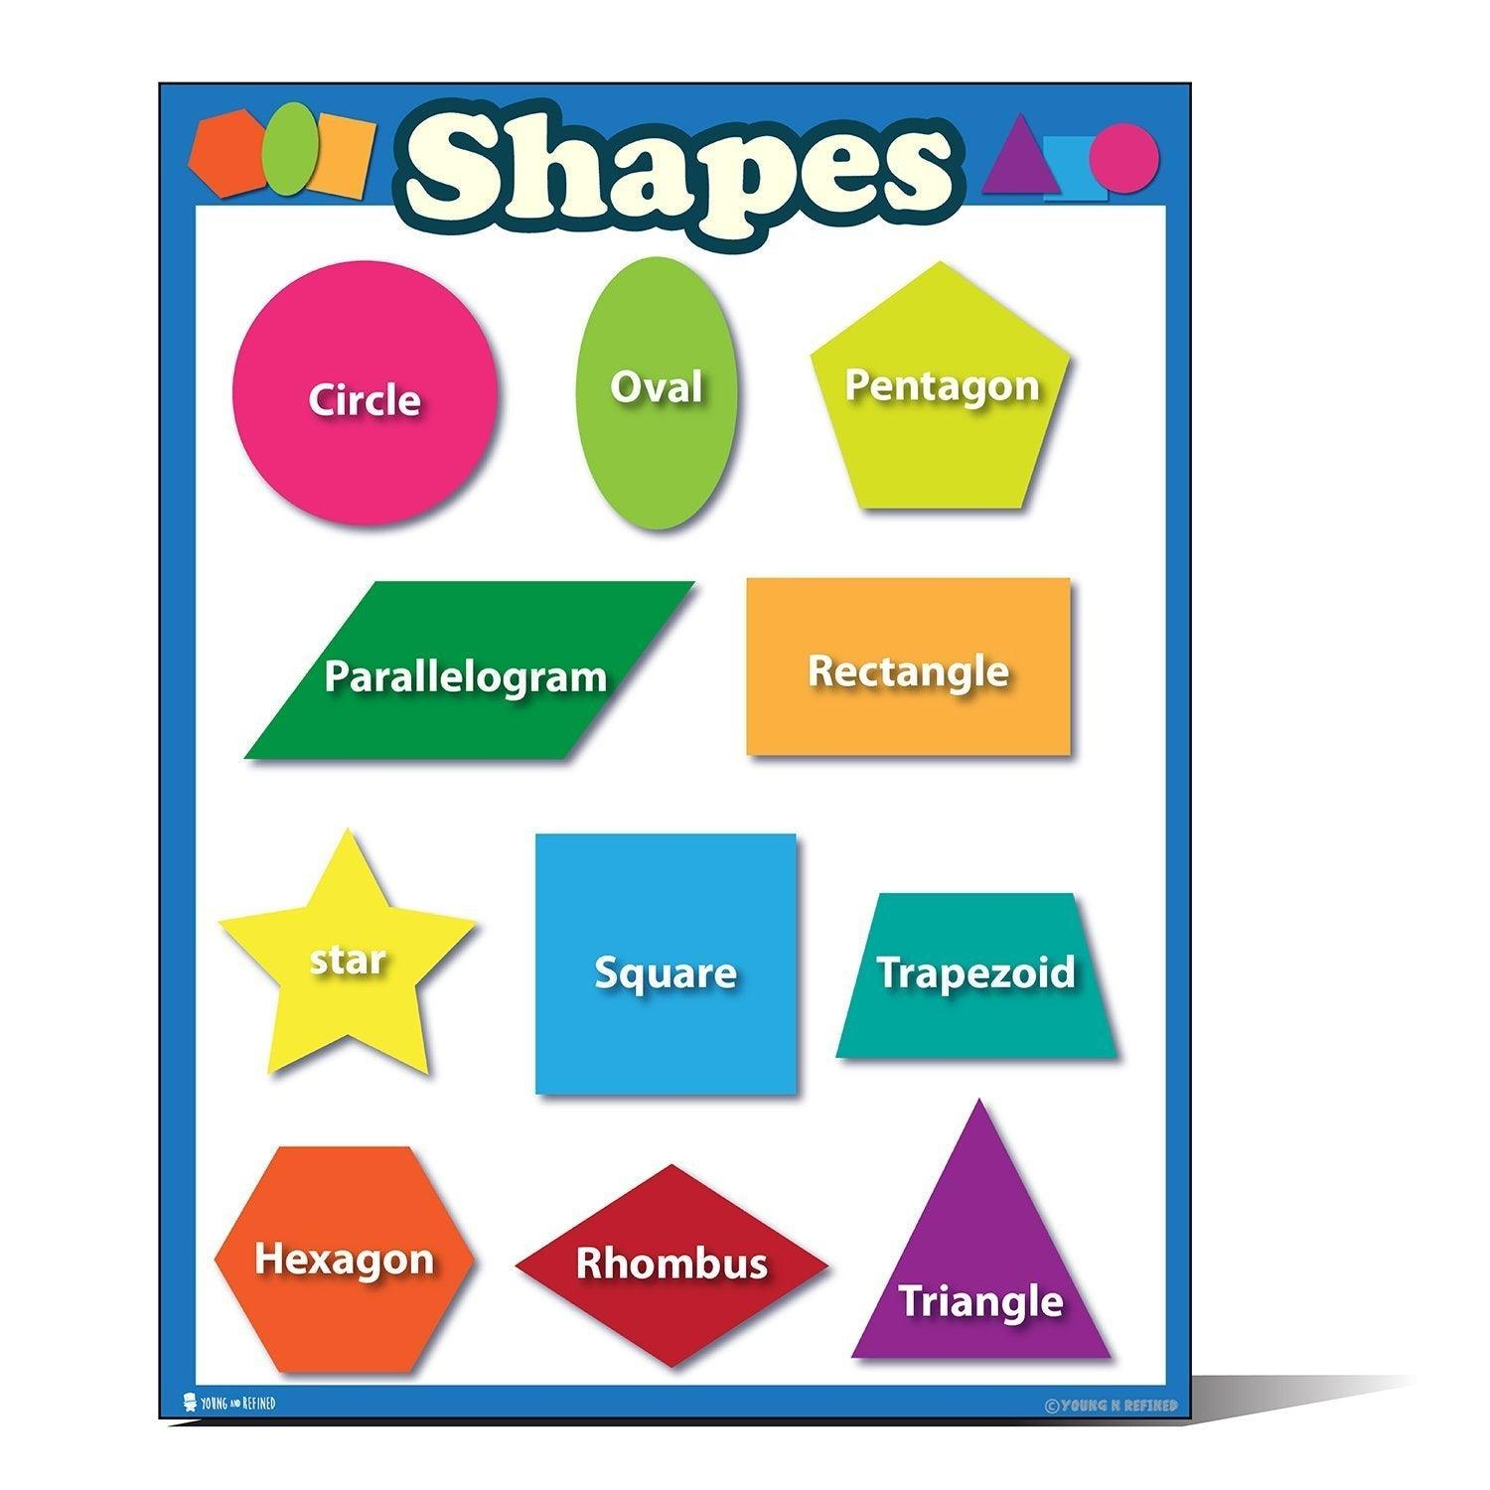
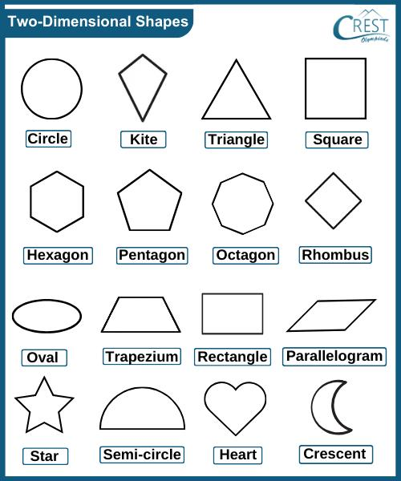
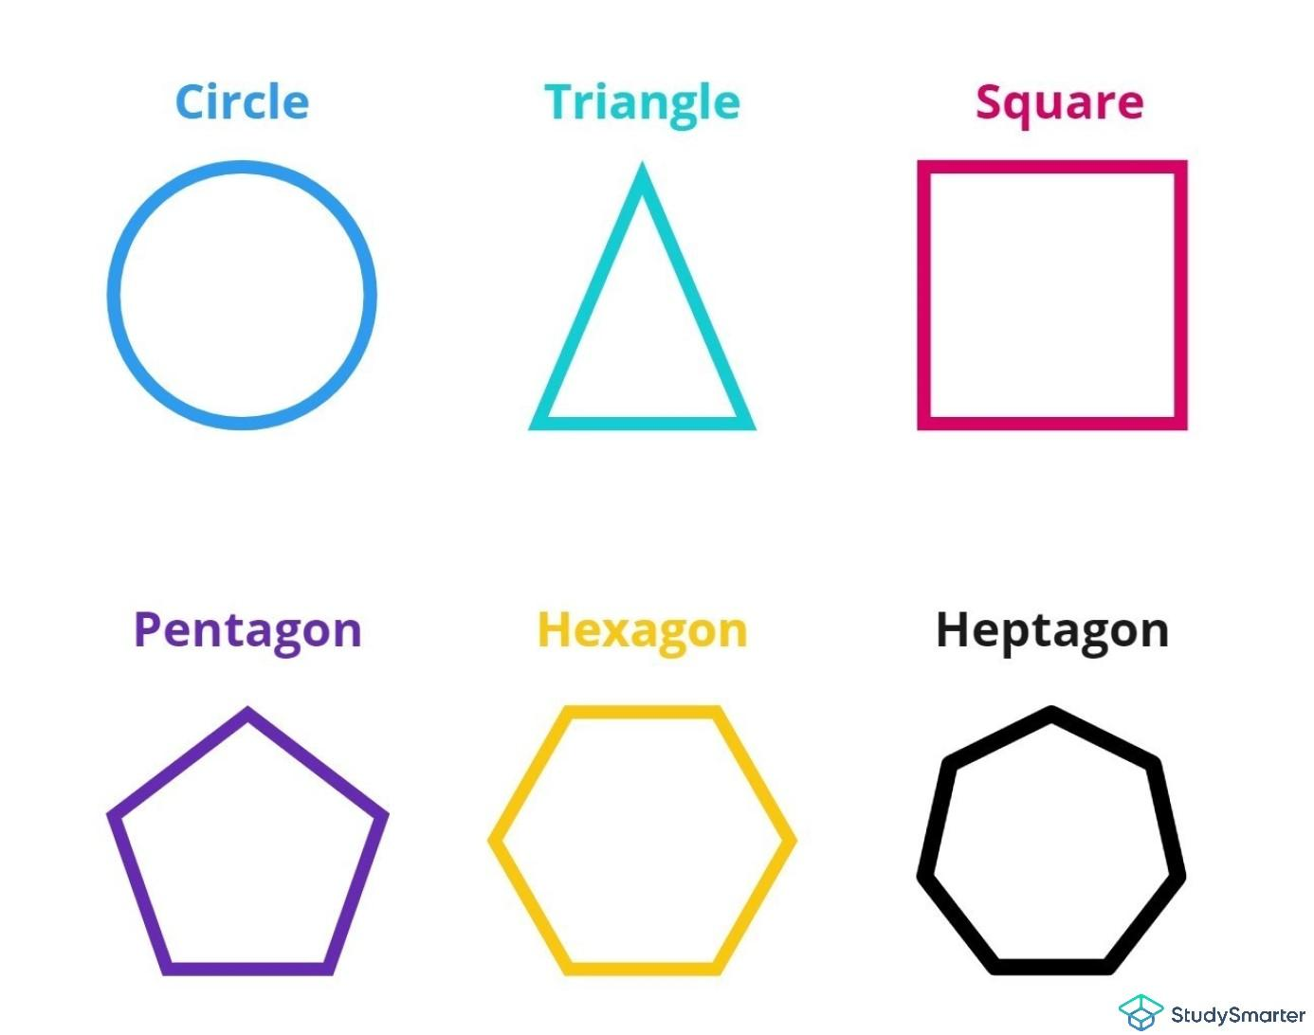
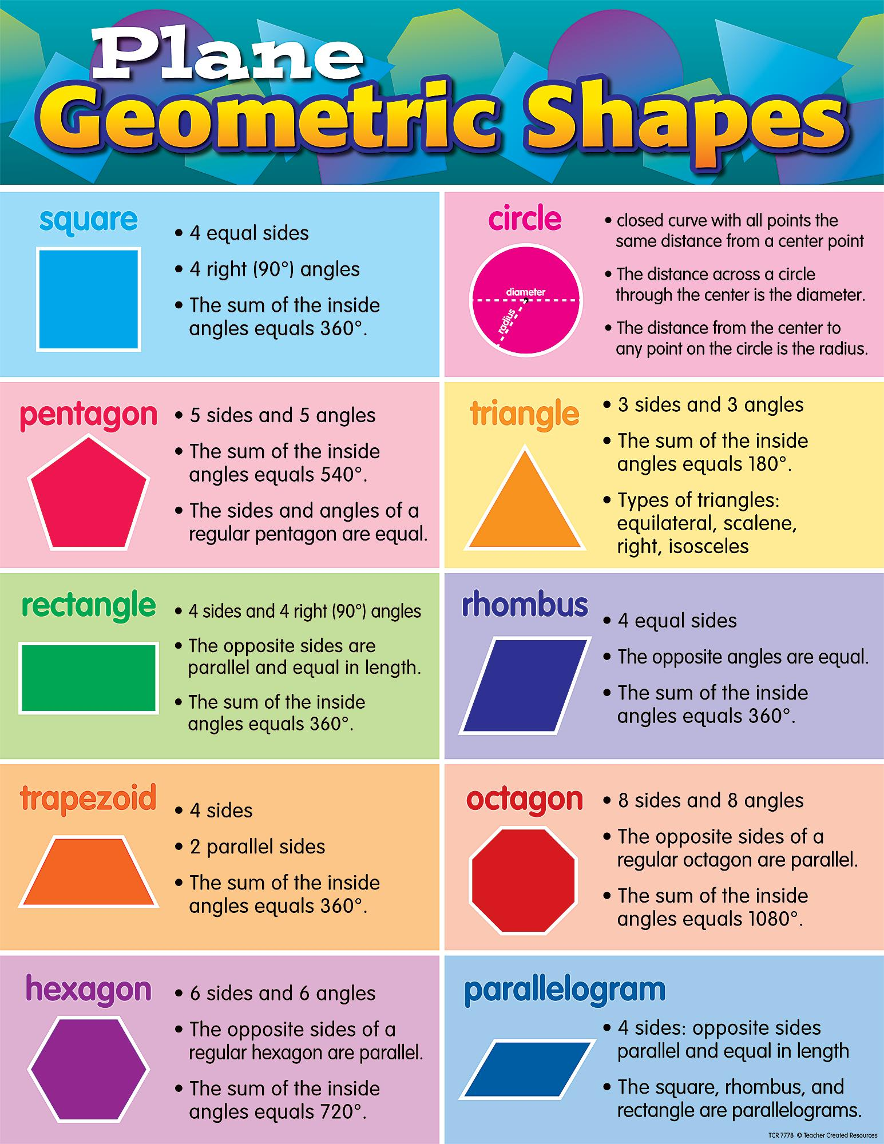
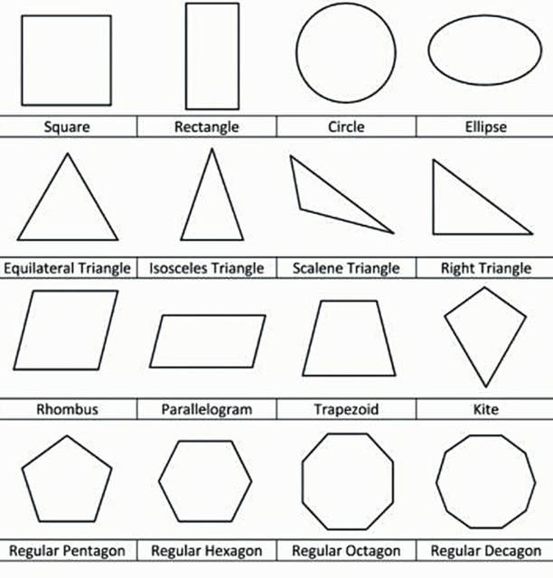

Definition
# Source: AI Source: Provided by: [Data Path: Persons Table -> ID Column: 1, Name_En Column: Motasem Essam] -> From: [ChatGPT] on [7/25/2026]
A Shape is a geometric figure formed by one or more boundaries that enclose or define a region on a plane. Shapes are two-dimensional (2D) objects that have length and width but no thickness.
A shape may be formed using:
- Straight line segments
- Curved lines
- Or a combination of both
Shapes are one of the fundamental objects studied in plane geometry.

Characteristics
# Source: AI Source: Provided by: [Data Path: Persons Table -> ID Column: 1, Name_En Column: Motasem Essam] -> From: [ChatGPT] on [7/25/2026]
A shape:
- Exists on a plane.
- Is two-dimensional.
- Has a boundary.
- May enclose an interior region.
- Has measurable geometric properties such as:
  - Area
  - Perimeter
  - Angles
  - Side lengths
- May be regular or irregular.
- May be open or closed (although most geometric shapes are closed).

Illustration

Simple Shape
# Source: AI Source: Provided by: [Data Path: Persons Table -> ID Column: 1, Name_En Column: Motasem Essam] -> From: [ChatGPT] on [7/25/2026]
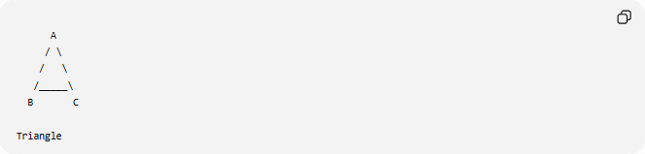
A
/ \
/ \
/_____\
B C

Triangle

Circular Shape
# Source: AI Source: Provided by: [Data Path: Persons Table -> ID Column: 1, Name_En Column: Motasem Essam] -> From: [ChatGPT] on [7/25/2026]
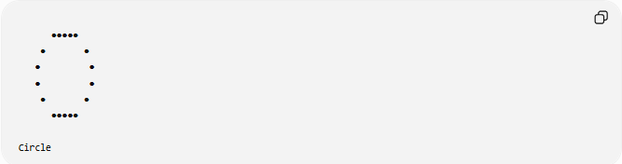
●●●●●
● ●
● ●
● ●
● ●
●●●●●

Circle

Rectangular Shape
# Source: AI Source: Provided by: [Data Path: Persons Table -> ID Column: 1, Name_En Column: Motasem Essam] -> From: [ChatGPT] on [7/25/2026]
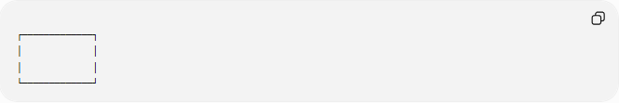
┌─────────────┐
│ │
│ │
└─────────────┘

Mathematical Representation
# Source: AI Source: Provided by: [Data Path: Persons Table -> ID Column: 1, Name_En Column: Motasem Essam] -> From: [ChatGPT] on [7/25/2026]
A shape is often represented as a set of points satisfying certain conditions.
Example:
Circle:
$$x^{2}+y^{2}≤r^{2}$$
Rectangle:
$$0≤x≤l, 0≤y≤w$$

Basic Elements of a Shape
# Source: AI Source: Provided by: [Data Path: Persons Table -> ID Column: 1, Name_En Column: Motasem Essam] -> From: [ChatGPT] on [7/25/2026]
Most shapes contain:
- Boundary
- Interior
- Exterior
- Vertices (for polygons)
- Sides or edges
- Angles (for polygons)

Classification of Shapes

Polygonal and Curved Shape

1. Polygonal Shapes
# Source: AI Source: Provided by: [Data Path: Persons Table -> ID Column: 1, Name_En Column: Motasem Essam] -> From: [ChatGPT] on [7/25/2026]
Formed entirely by straight line segments.
Examples:
- Triangle
- Quadrilateral
- Pentagon
- Hexagon
- Octagon

2. Curved Shapes
# Source: AI Source: Provided by: [Data Path: Persons Table -> ID Column: 1, Name_En Column: Motasem Essam] -> From: [ChatGPT] on [7/25/2026]
Formed by curved boundaries.
Examples:
- Circle
- Ellipse
- Oval

3. Mixed Shapes
# Source: AI Source: Provided by: [Data Path: Persons Table -> ID Column: 1, Name_En Column: Motasem Essam] -> From: [ChatGPT] on [7/25/2026]
Contain both straight and curved boundaries.
Examples:
- Semicircle
- Stadium shape
- Rounded rectangle

Regular and Irregular Shapes

Regular Shapes
# Source: AI Source: Provided by: [Data Path: Persons Table -> ID Column: 1, Name_En Column: Motasem Essam] -> From: [ChatGPT] on [7/25/2026]
A regular shape has:
- Equal sides.
- Equal angles.
Examples:
- Square
- Equilateral Triangle
- Regular Pentagon

Irregular Shapes
# Source: AI Source: Provided by: [Data Path: Persons Table -> ID Column: 1, Name_En Column: Motasem Essam] -> From: [ChatGPT] on [7/25/2026]
An irregular shape has:
- Unequal sides and/or
- Unequal angles.

Open and Closed Shapes

Closed Shapes
# Source: AI Source: Provided by: [Data Path: Persons Table -> ID Column: 1, Name_En Column: Motasem Essam] -> From: [ChatGPT] on [7/25/2026]
The boundary forms a complete loop.
Examples:
- Circle
- Square
- Triangle
Closed shapes enclose an interior region.

Open Shapes
# Source: AI Source: Provided by: [Data Path: Persons Table -> ID Column: 1, Name_En Column: Motasem Essam] -> From: [ChatGPT] on [7/25/2026]
The boundary does not completely enclose a region.
Example:
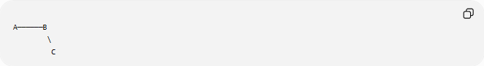
A──────B
\
C
This is not considered a plane figure in the strict geometric sense because it does not enclose an area.

Convex and Concave Shapes

Convex Shapes
# Source: AI Source: Provided by: [Data Path: Persons Table -> ID Column: 1, Name_En Column: Motasem Essam] -> From: [ChatGPT] on [7/25/2026]
A Convex Shape is a shape where all parts of the boundary curve outward, and no part of the shape is pushed inward.
Examples:
- Square
- Rectangle
- Triangle
- Regular Pentagon
Convex shapes have no inward dents, and all interior angles are less than ${180}^{∘}$.

Concave Shapes
# Source: AI Source: Provided by: [Data Path: Persons Table -> ID Column: 1, Name_En Column: Motasem Essam] -> From: [ChatGPT] on [7/25/2026]
A Concave Shape is a shape that has at least one part of its boundary pushed inward, creating an indentation or dent.
Examples:
- Concave Pentagon
- Star-shaped Polygon
- Arrow-shaped Polygon
Concave shapes contain at least one interior angle greater than ${180}^{∘}$.

Common Plane Shapes
# Source: AI Source: Provided by: [Data Path: Persons Table -> ID Column: 1, Name_En Column: Motasem Essam] -> From: [ChatGPT] on [7/25/2026]
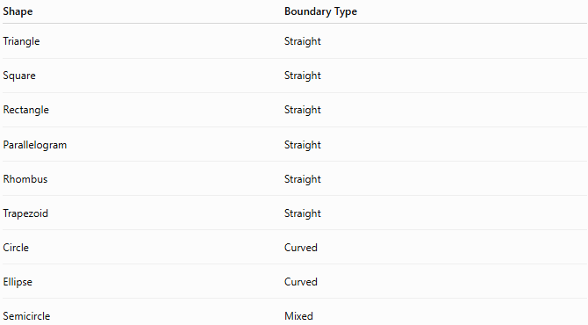
Shape | Boundary Type
Triangle | Straight
Square | Straight
Rectangle | Straight
Parallelogram | Straight
Rhombus | Straight
Trapezoid | Straight
Circle | Curved
Ellipse | Curved
Semicircle | Mixed

Properties of Shapes
# Source: AI Source: Provided by: [Data Path: Persons Table -> ID Column: 1, Name_En Column: Motasem Essam] -> From: [ChatGPT] on [7/25/2026]
Shapes may have:
- Area.
- Perimeter.
- Symmetry.
- Congruence.
- Similarity.
- Rotation.
- Reflection.
- Translation.

Real-World Examples
# Source: AI Source: Provided by: [Data Path: Persons Table -> ID Column: 1, Name_En Column: Motasem Essam] -> From: [ChatGPT] on [7/25/2026]
Shapes appear in:
- Buildings.
- Windows.
- Roads.
- Coins.
- Traffic signs.
- Mobile phone screens.
- Sports fields.
- Maps.
- Furniture.
- Art and logos.

Applications
# Source: AI Source: Provided by: [Data Path: Persons Table -> ID Column: 1, Name_En Column: Motasem Essam] -> From: [ChatGPT] on [7/25/2026]
Shapes are fundamental in:
- Plane Geometry
- Coordinate Geometry
- Analytic Geometry
- Engineering
- Architecture
- Surveying
- CAD (Computer-Aided Design)
- Computer Graphics
- GIS (Geographic Information Systems)
- Robotics
- Industrial Design

Advantages
# Source: AI Source: Provided by: [Data Path: Persons Table -> ID Column: 1, Name_En Column: Motasem Essam] -> From: [ChatGPT] on [7/25/2026]
Studying shapes helps to:
- Compute area and perimeter.
- Describe objects mathematically.
- Design engineering structures.
- Model real-world objects.
- Analyze spatial relationships.
- Understand symmetry and transformations.

Limitations
# Source: AI Source: Provided by: [Data Path: Persons Table -> ID Column: 1, Name_En Column: Motasem Essam] -> From: [ChatGPT] on [7/25/2026]
Plane shapes:
- Exist only in two dimensions.
- Have no thickness.
- Cannot directly represent three-dimensional objects.

Comparison with Related Concepts
# Source: AI Source: Provided by: [Data Path: Persons Table -> ID Column: 1, Name_En Column: Motasem Essam] -> From: [ChatGPT] on [7/25/2026]
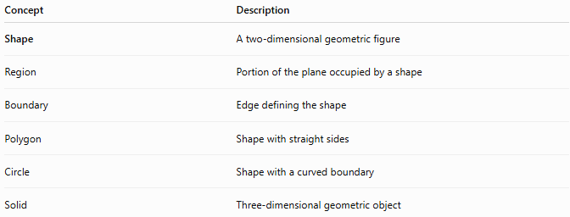
Concept | Description
Shape | A two-dimensional geometric figure
Region | Portion of the plane occupied by a shape
Boundary | Edge defining the shape
Polygon | Shape with straight sides
Circle | Shape with a curved boundary
Solid | Three-dimensional geometric object

Key Points
# Source: AI Source: Provided by: [Data Path: Persons Table -> ID Column: 1, Name_En Column: Motasem Essam] -> From: [ChatGPT] on [7/25/2026]
- A Shape is a two-dimensional geometric figure.
- It is defined by a boundary.
- Shapes may be:
  - Polygonal.
  - Curved.
  - Mixed.
- Shapes can be:
  - Regular.
  - Irregular.
  - Open.
  - Closed.
- Closed shapes enclose regions with measurable area.

Conclusion
# Source: AI Source: Provided by: [Data Path: Persons Table -> ID Column: 1, Name_En Column: Motasem Essam] -> From: [ChatGPT] on [7/25/2026]
A Shape is a two-dimensional geometric figure defined by one or more boundaries on a plane. Shapes may be formed from straight lines, curves, or both, and are classified into categories such as polygons, curved figures, and mixed figures. They are fundamental in plane geometry, coordinate geometry, analytic geometry, engineering, architecture, surveying, CAD, GIS, robotics, computer graphics, and industrial design, where they are used to describe, measure, analyze, and model objects and spaces in both mathematics and the real world.

